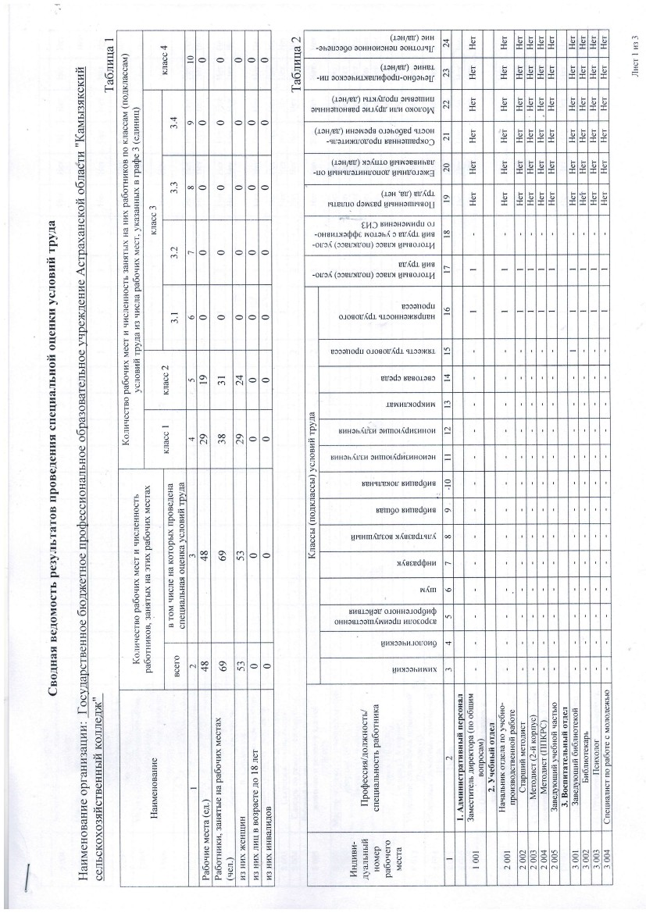

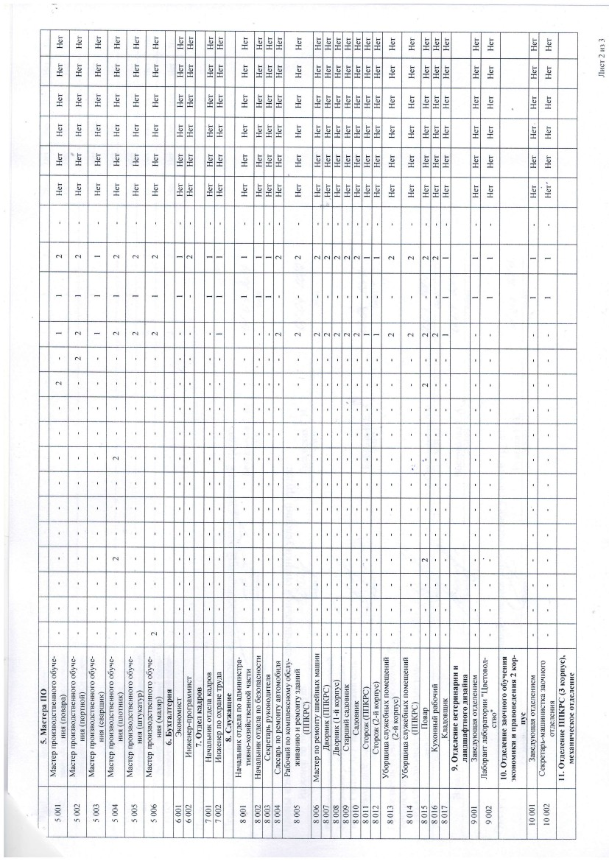

F

>x

O

AI

ca

4

F

X

I

F

U

6+

tr

o,:<

o

I9

:

FI

o'l

N

N

F

o

L

v

o q

q

5

q

6

oo

F

o

AN

C€

O

o

vl

I

f,l,tm

>r,4eeedQur.r

co

$

sao

o ;.

>;

XiE

Fx

q)

2

€

F

x

d

4rrx m,{trcos xAsced-tc u,{

.X

XF

36

o\

rHne09140

N

H

r)

HX

I^l

!l14xc0hrl

ca

s

oo

F.

!

d

39

KhxcehhJorioH9

ul4sJcHev o.roHuarodgr.rQ

uuocodeB

oHHOSJ3aE,{Nr.iedu

so

z=

F

Q

o

o

d

o

Q1

XI

VI

?

C)

-l

tr

cC

O

E

I

d

o

R

U

X

N

eIsqu

o

o

O

N

N

N

T

o

x

X

?-

90

lr' ()lol

4l

o

N

L

F

x

F

o

a

F

-|_

C)

E

F

9'

!9

9X

F

F

i(Y

ll

X

0)l

;r

d

o

o

F,I

o

.nl

FI

()I

d

I

l:

=A

d

m

a

r

t

P*

oxouot\

$

ts

T

T T

E

F

o

F

o

:E

N

N

(reH/ev) HHawade o:ar'ogud srcox

ur.r

n

ersHHenoH ged ou.r,{dv

6H

>:

F

E

F

q

:t

o

f

N

!: F F Fo

:E :E

F FFo Fo

:E E x

I

o

F

o

F

F

a

:E

N

(reH/sv) xc,turo Hrrneeau neu

-uo Hr9Hquel.uHrrouoE r rqHVoJ0)r(3

-qraruxrovodu sBHHotfl€dxo']

!o

u3

F

o

F

T

T

F

ts

F

o

T

I

F F

a o

F

F

r+

N

-0heuce9o 0oHHor,tcHSu eoHJoJ<rLl'

I

cg

$

I

(€

N

(reH/€v) or.H

o

F F F

o

:E :r

F

F F F

o

:E E x

F

FFa o

E :c T

(-

L

o

6PH<lu?xou Br4nPdgHg

N

(raHptT) lsJJ,ft/odu erqselnHU

-uu oovcohrll)IPrH0odil-oHgehau

(roH/Bv) aHH€r

\a

F

F

E

+

oh

H€h n

n,{rsn eilmor,{d

uu sa

00

6

c.l

9

N

rewhuxooxuhJ

c\

evedc ruso.Lesc

v

c!

co

N

F

si

:-

x)I

9>'

Yz

ruln90

I

00

Pl&

=9

xtr

9a

dtr

F

T

cd,

d

X

(d

4F

FO

D

o14nor^d14fl4HoHoH

shHal'Arth

Hr<rHHamr<lsoLI

F F

:E T

F

a

E E

T

T

T

F F o FF

o

F

o

o\

\o

(r-rH 'uv) uv^dl

rcretruo danr?d

€

I

hX

rX=

F F F F

T T :E :E

F

a

:c

F

(g

a

€cceroou

oJosoV{dl crsosHaxrdueH

€

sv^dr Fhs

-otrJ^ (Jcutrxvou) ccurx 4tseo:orq

&4J cnHoHant du oJ

-onanuraQQe noror',{ c Pr,{fu f HB

-orc^ (ooBuxvou) ccurx 4rseolo16

r

N

v

...

rN

oo

o*

I

>.

xU

;9

Fx

t

>1

q3

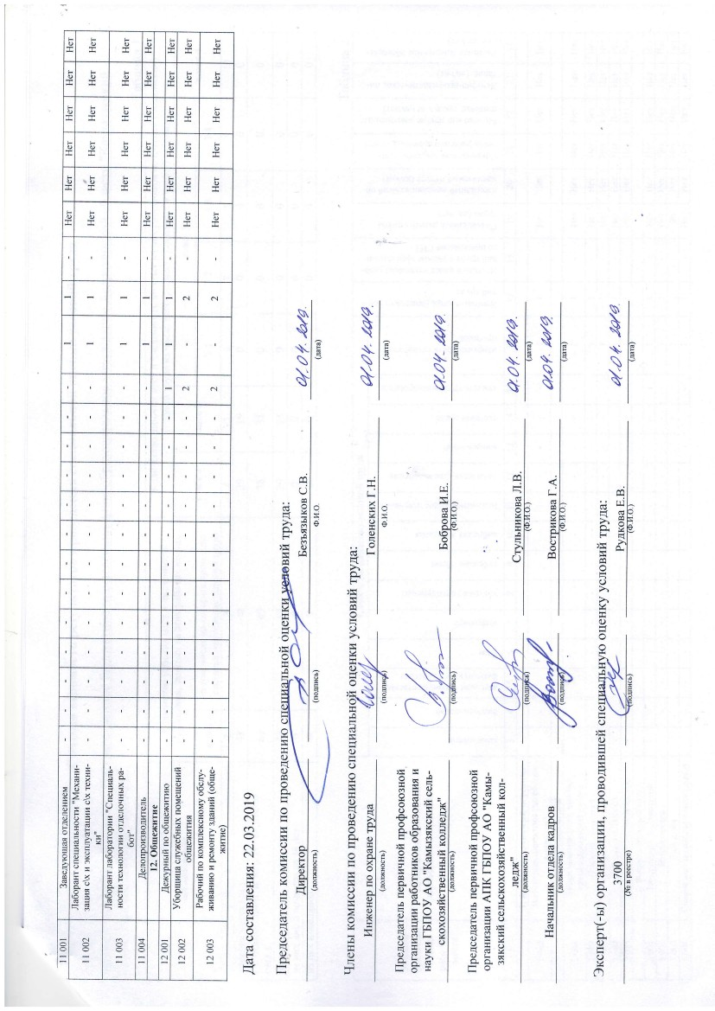

N

t

N

cl

N

N

N

N

N

N

N

N N c.l N

N

N

r

(\

N

c.l c.l

N

o.l

N N G N N

N

N

fl

N

N

N

o

F d

9?

m

P

E> e^

6i! xq

F2

OY

9,^

6v

F

6d

FE

?-

5

N

EA.

ro

a

X

:

>!

o)5

q

F

F

g

J

q

T

F

F F

F

i

E

T

F

I

F

T

o

T T

F

F

F

E

T

I

I

ts

F

o

F

a

E

E

F

F

F

F

o

r

I

E

E

I

.t-

F

ts

F

U

T

E

6>

E

I

F F F F

:c E E T T

I

F

ts

o

E

T T

;c

E

T

.a)

5

v!

::

6

m

A:

=

a

Q

I

s

I

l,)

cd

i.J

.)

F

d

\o

FX

rr9

vi

o

o

*r

;.1

B5

5d

9:;

r

o

€ €€€

€ €

a

€

X

X

€ €

€€ €

r r

N

N

O

N

r x

€

*

@

N

d

G

O

O

O

N

d9

q

rF

v

V =r'

d ox

*U

= XF

=

o

F

o6

o

a

:E

s

r

5

I

J

v

Fq os

E

-

o.

90

(J

o

e

d

I

o

o=

FJZ

A,+

gE

e oi

q

x

-

*.)

(J

5cJ

L)

o

l-

E!

CF

EQ

\ov

F

Y9

EF

X9

N

l.

F

a

O

o

F)'

E;;

=;

o

F

:E

:d

F

o

T

I

F

F

G

T T T T

F

o F

F

o

E

F

I

F

F

T :E

I

T

F

o

:E

F

:E

E

:E

F

F

bi

I I

F

F F

o o

T I

b.

F

o 6

E T

F

F

:E

:c

ii

F

F

a

E

F

o

F

F

o

T

F

F

o

F

orr!

F

I

o

I

ts

T

F

F ts F

orr,:r,

F

E

F

F

tso

I

F

T

F

I

F

F o FFo

:E

:E

F

F

F

q

F

F

E

F

F

:E

T

F

F

T

:E

F

F

o

F

I E

F F

F

a

F

T

F

E

:E

F

o

F F

F

F

F F F

I T

F

E

Fc ts

T T

F

:c

F

F

F

F

:E

-

F

a

E

F

F

F

T I

ts

I

F

F

F F

E I

f

F

F

c

F

I E

I

F

a

T

E

F

!:

F F F

o

t I

T I

F

E

T

F

E

F

ts

a

T

:E

Fc

E

F

F

T

F

T

:E

F

T

I

I

T

F

F

F

x

F

x

o

T T

F

? F

D

F

o

F

:E

I I I

T

F

F

F

s

I

:E

F

a

F

:c

F

F

F

o

F

:c

T

F F

I T

a

F

T

:E

F

E

F

E

:E

F

E

:E

F.

F

ts

F

F

E

:E

F

o

4

H>:

.ic!Y

I

tsnE

P< E

r>E

,89.8

E\-/ -

x= ,*

I

ol

I

-

H5Ae-

c)

vl

cvl

E{ E

F.50

g\o<

!2

F

t!!- g

F

c{

9x*

=

4

-

c.l

ca

H

()

O

E FI8;'4 s x e5F

N

(.)

o

C)

-

H

aF'tx

XYUr{

EX 9 g

BH5 5

96E,5

* EJ 4

)S-{F

Q

H.A5

O

E!;

=

F

H

R

d

|-

o

H

O

art

=dH^dHLV

9ise

xesr

xt>

LOJ-*=

xr?o

F!5

9:c6

x!Esz

tEl

I

I

I

I

ti

()

F

I

(sl

s!lQ<u oX

dtrv-

=4

=<Eh=o)

<)

O

x

I

otx

F II

sld

)!iSl

i: t-

a

I

Fi

H

(J

-

o QlrS R

- -A? rL./ o

v.

s

;

I

f

;?Y

6U

F!a

x*

=

X

;L

Q

xfl

1t

tl

I

I

>' PF

4

-J

IJT F

(tp

q)

)sE

NIN 8N,

t\

$ gd \

J\

N

3

F

N

N

N

\

*

\

n

\

\i

N[\

I

I

N

I

I

I

Q

q)

I

>.

I

4

A\

ol

4

c.)

>'

c)

F

I

I

H

q)

-

4

a.)

*

-

,

U

n

ol

I

FI

* vle

- x

'l

I

\

\

>.

v

0')

I

O

I

I

I